IMPLEMENT CLIENT SCRIPT & UI POLICY (INCIDENT)
PROJECT REPORT
ServiceNow Incident Management

ABSTRACT
The Implement Client Script & UI Policy (Incident) project demonstrates the use of ServiceNow client-side controls to improve the quality, consistency, and reliability of Incident records. The project focuses on implementing UI Policies and Client Scripts to control the behavior of fields on the Incident form.
In a standard Incident management process, users may enter incomplete information, modify fields incorrectly, or submit records without providing important details. Such situations can affect Incident assignment, prioritization, reporting, and resolution. To address these problems, this project introduces dynamic form controls and validation mechanisms.
UI Policies are used to make fields mandatory, control field behavior, and make selected fields read-only when specific conditions are satisfied. Client Scripts are used for event-based operations such as onLoad, onChange, onSubmit, and onCellEdit. The project also demonstrates automatic handling of related values, validation of required information, and prevention of invalid submissions.
The overall implementation provides a controlled Incident-entry process in which users receive immediate feedback and are guided to provide complete and valid information.

TABLE OF CONTENTS
- Introduction
- Project Overview
- Problem Statement
- Objectives
- Scope of the Project
- Existing System
- Proposed System
- Functional Requirements
- Non-Functional Requirements
- Tools and Technologies
- ServiceNow Incident Management
- UI Policies
- Client Scripts
- GlideForm API
- System Architecture
- Application Flow
- System Navigation
- Detailed Implementation
- UI Policy Implementation
- onLoad Client Script
- onChange Client Script
- onSubmit Client Script
- onCellEdit Client Script
- Assigned To Validation
- Data Validation and Integrity
- Testing Methodology
- Test Cases
- Test Results
- Error Handling
- Security Considerations
- Performance Considerations
- Advantages
- Limitations
- Future Enhancements
- Deployment and Maintenance
- Troubleshooting
- Project Outcomes
- Conclusion
- References
- Appendix

1. INTRODUCTION
ServiceNow is a cloud-based platform used by organizations to manage IT services, incidents, requests, workflows, and other enterprise processes. It provides a centralized environment for recording and managing incidents throughout their lifecycle.
Incident Management is an important part of ServiceNow because it allows organizations to record issues, assign them to appropriate teams, prioritize them, track their progress, and eventually resolve them.
For an Incident Management system to work effectively, the information stored in Incident records must be complete and consistent. If users leave important fields empty or enter incorrect combinations of values, the quality of the Incident record can be affected.
This project focuses on improving Incident data quality using UI Policies and Client Scripts.
UI Policies provide declarative control over form fields. They can make fields mandatory, read-only, or control their behavior based on conditions.
Client Scripts provide JavaScript-based functionality that runs on the client side. They can respond to events such as loading a form, changing a field, submitting a form, or editing a field directly from a list.
The combination of these features allows the Incident form to become more interactive and controlled.

2. PROJECT OVERVIEW
The project titled “Implement Client Script & UI Policy (Incident)” is designed to demonstrate practical ServiceNow configuration and scripting.
The main purpose of the project is to enforce data-entry rules on Incident records.
Project Component | Description
Platform | ServiceNow
Module | Incident Management
Main Table | Incident
Configuration | UI Policies
Scripting | Client Scripts
Language | JavaScript
API | GlideForm
Events | onLoad, onChange, onSubmit, onCellEdit
Main Goal | Improve Incident data integrity
The implementation controls the Incident form dynamically according to predefined conditions.

3. PROBLEM STATEMENT
In an Incident Management system, users are responsible for entering information into different fields of an Incident record.
Without appropriate controls, several problems may occur:
- Important fields may be left empty.
- Users may enter inconsistent information.
- Controlled fields may be modified unnecessarily.
- Related fields may not be updated automatically.
- Invalid Incident records may be submitted.
- Incorrect State values may be changed through inline editing.
- Additional manual correction may be required.
These problems can reduce the reliability of Incident records.
Therefore, the project introduces UI Policies and Client Scripts to provide dynamic form behavior and validation.

4. OBJECTIVES
The major objectives of the project are:
- To understand ServiceNow Incident Management.
- To implement UI Policies on the Incident form.
- To implement Client Scripts for different form events.
- To make selected fields mandatory when required.
- To control field behavior dynamically.
- To make selected fields read-only.
- To automatically handle related field values.
- To validate required information before submission.
- To validate the Assigned To field where required.
- To control inline State editing.
- To prevent invalid Incident submission.
- To improve Incident data consistency.
- To provide immediate feedback to users.
- To gain practical experience in ServiceNow administration and scripting.

5. SCOPE OF THE PROJECT
5.1 In Scope
The project includes:
- Incident form configuration
- UI Policy creation
- UI Policy Actions
- Mandatory field control
- Read-only field control
- Reverse-if-false behavior
- Client Script creation
- onLoad scripting
- onChange scripting
- onSubmit validation
- onCellEdit control
- Assigned To validation
- Impact and Urgency interaction
- Testing and validation
5.2 Out of Scope
The following areas are outside the primary scope:
- Complete enterprise Incident automation
- External application integration
- Custom ServiceNow portal development
- Advanced server-side development
- Enterprise security architecture
- Large-scale performance testing

6. EXISTING SYSTEM
In a basic Incident form, users can enter information manually.
Although ServiceNow provides standard Incident functionality, project-specific rules may not automatically exist for every organization.
Some common issues are:
Problem | Effect
Required field is empty | Incomplete record
Incorrect field combination | Inconsistent information
Controlled field is editable | Unwanted modification
Missing Assigned To | Unclear ownership
Invalid submission | Poor data quality
Uncontrolled State editing | Workflow inconsistency
The existing approach therefore depends heavily on the user entering correct information.

7. PROPOSED SYSTEM
The proposed system introduces client-side controls to improve the Incident form.
The system consists of:
UI Policies
Used for:
- Mandatory fields
- Read-only fields
- Dynamic field behavior
- Reverse-if-false behavior
Client Scripts
Used for:
- Form loading
- Field changes
- Submission validation
- Inline editing
The proposed system provides immediate feedback to users and reduces common data-entry errors.

8. FUNCTIONAL REQUIREMENTS
The system shall:
- Apply the configured UI Policies.
- Make selected fields mandatory.
- Make selected fields read-only.
- Reverse field behavior when required.
- Respond when Impact changes.
- Control the corresponding Urgency value according to the project rule.
- Validate required fields before submission.
- Validate Assigned To where required.
- Control inline State editing.
- Prevent invalid submission.
- Display appropriate messages to the user.

9. NON-FUNCTIONAL REQUIREMENTS
The project should satisfy the following requirements:
- The configuration should be easy to understand.
- Scripts should be readable.
- Validation messages should be clear.
- Client-side processing should be efficient.
- Configuration should be tested properly.
- Changes should be documented.
- Production deployment should follow approved procedures.

10. TOOLS AND TECHNOLOGIES
Tool / Technology | Purpose
ServiceNow | Main development platform
Incident Management | Application/module
JavaScript | Client-side scripting
GlideForm | Form interaction
UI Policies | Dynamic field behavior
Client Scripts | Event-based logic
Browser Developer Tools | Debugging
Update Sets | Configuration deployment

11. SERVICENOW INCIDENT MANAGEMENT
Incident Management is used to record and manage incidents reported by users or detected by an organization.
Important Incident fields include:
Field | Purpose
Number | Unique Incident number
Caller | Person reporting the incident
Short Description | Brief issue description
Description | Detailed issue information
Impact | Business effect
Urgency | Required response speed
Priority | Incident priority
Assignment Group | Responsible support group
Assigned To | Responsible individual
State | Current Incident status
The project primarily focuses on controlling the behavior of selected fields.
Screenshot – Incident Form
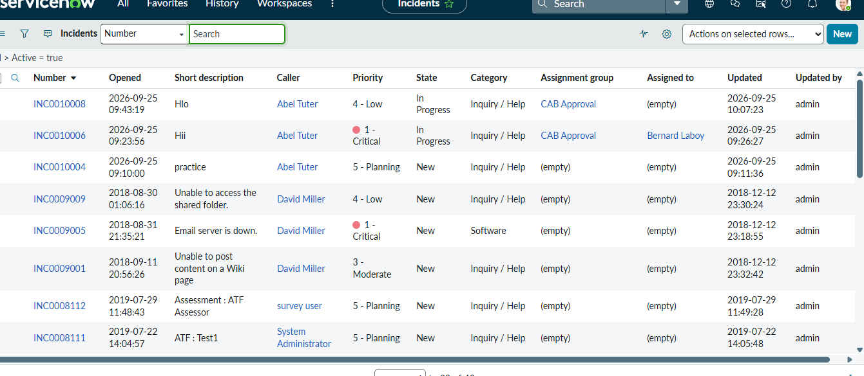
Figure 1: ServiceNow Incident Form

12. UI POLICIES
A UI Policy is a ServiceNow configuration used to dynamically change the behavior of fields on a form.
UI Policies can be used to:
- Make fields mandatory
- Make fields read-only
- Make fields visible
- Reverse field behavior when conditions change
They are useful when simple field behavior can be implemented without writing JavaScript.
12.1 Mandatory Field
When the configured condition becomes true, the selected field becomes mandatory.
The user must provide a value before the Incident can be submitted.
12.2 Read-Only Field
A field can be made read-only when a particular condition is satisfied.
This prevents normal user editing of the field.
12.3 Reverse if False
The Reverse if false option allows the original behavior of the field to be restored when the UI Policy condition becomes false.
Screenshot – UI Policy
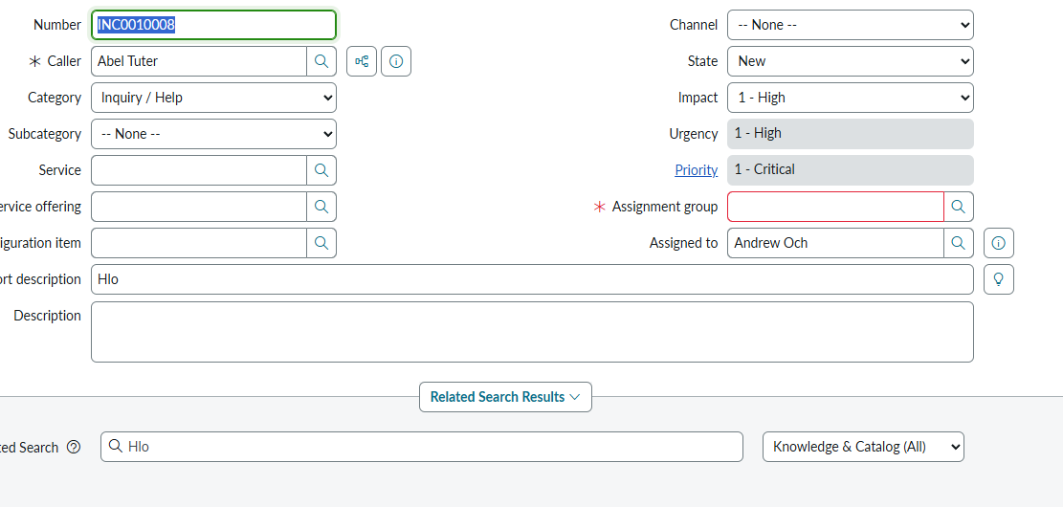
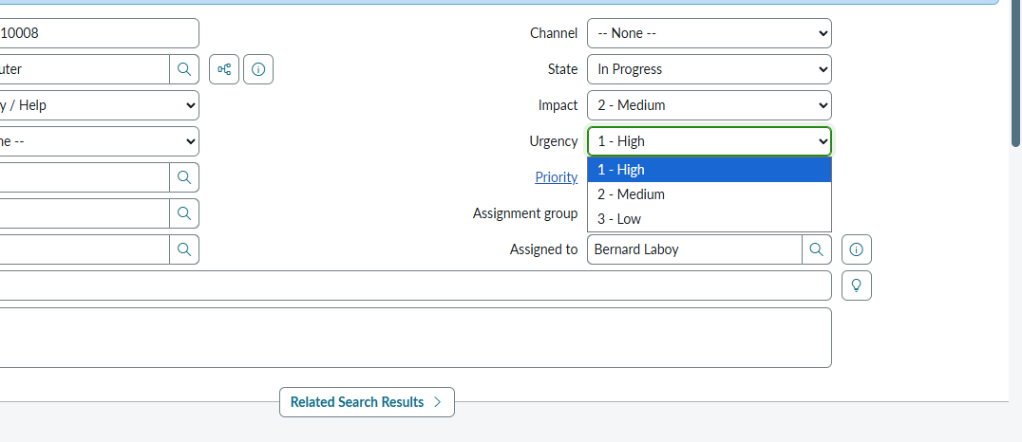
Figure 2: UI Policy Configuration

13. CLIENT SCRIPTS
A Client Script is JavaScript that executes on the client side of the ServiceNow form.
The main Client Script types used in this project are:
Type | Purpose
onLoad | Executes when form loads
onChange | Executes when field changes
onSubmit | Executes before form submission
onCellEdit | Executes during list cell editing
Each script type has a specific purpose.

14. GLIDEFORM API
ServiceNow provides the GlideForm API, commonly accessed through g_form, for interacting with form fields.
It can be used to:
- Get field values
- Set field values
- Make fields mandatory
- Make fields read-only
- Display messages
- Clear values
- Control form behavior
Examples of commonly used methods include:
g_form.getValue()
g_form.setValue()
g_form.setMandatory()
g_form.setReadOnly()
The exact methods used depend on the project requirement.

15. SYSTEM ARCHITECTURE
The project follows a client-side architecture:
SERVICE NOW
|
↓
INCIDENT FORM
|
---------------------
| |
↓ ↓
UI POLICIES CLIENT SCRIPTS
| |
↓ ↓
Mandatory / Read-only Event-based Logic
| |
-----------+---------
|
↓
VALIDATION
|
--------------
| |
YES NO
| |
↓ ↓
SAVE RECORD SHOW MESSAGE
The architecture ensures that user interaction is controlled according to the project requirements.

16. APPLICATION FLOW
The application flow is:
START
↓
Open Incident Form
↓
UI Policies Evaluate Conditions
↓
Apply Mandatory / Read-only Behavior
↓
User Enters Incident Information
↓
Impact Changed?
↓
onChange Client Script
↓
Update Urgency According to Rule
↓
User Completes Required Fields
↓
Submit Incident
↓
onSubmit Validation
↓
Is Data Valid?
├── YES → Save Incident
└── NO → Display Error Message
Screenshot – Application Flow Diagram
[INSERT YOUR FLOW DIAGRAM HERE]
Figure 3: Application Flow

17. SYSTEM NAVIGATION
The basic navigation for the project is:
- Log in to ServiceNow.
- Open the Application Navigator.
- Search for Incident.
- Open the Incident module.
- Create or open an Incident.
- Test the configured UI Policies.
- Change Impact.
- Verify Urgency behavior.
- Test Assigned To validation.
- Submit the Incident.
- Test inline State editing.
Screenshot – Application Navigator
[INSERT SCREENSHOT HERE]
Figure 4: ServiceNow Application Navigator

18. DETAILED IMPLEMENTATION
The implementation is divided into several stages.
Step 1 – Identify Incident Fields
The fields involved in the requirements are identified.
Examples:
- Impact
- Urgency
- Assigned To
- State
- Other required project fields
Step 2 – Configure UI Policies
UI Policies are created for field behavior.
Step 3 – Configure Client Scripts
Client Scripts are created according to the required event.
Step 4 – Test Dynamic Behavior
Each condition is tested separately.
Step 5 – Test Invalid Data
Incorrect or incomplete information is entered to verify validation.
Step 6 – Record Evidence
Screenshots are captured for important configurations and test results.

19. UI POLICY IMPLEMENTATION
The UI Policy configuration generally contains:
Configuration | Description
Name | Meaningful policy name
Table | Incident
Condition | Rule that activates the policy
UI Policy Action | Field behavior
Mandatory | Makes field required
Read-only | Prevents editing
Reverse if false | Restores behavior
Configuration Procedure
- Open the Incident UI Policies.
- Select New.
- Enter the policy name.
- Select the Incident table.
- Define the condition.
- Save the UI Policy.
- Create the required UI Policy Action.
- Configure Mandatory or Read-only.
- Enable Reverse if false where necessary.
- Save and test.
Screenshot
[INSERT UI POLICY SCREENSHOT]
Figure 5: UI Policy Configuration
Screenshot
[INSERT UI POLICY ACTION SCREENSHOT]
Figure 6: UI Policy Action

20. ONLOAD CLIENT SCRIPT
The onLoad Client Script executes when the Incident form loads.
It can be used to apply initial client-side behavior.
General Logic
Form Loads
↓
Read required values
↓
Evaluate conditions
↓
Apply initial behavior
A basic structure is:
function onLoad() {
// Project-specific initialization
}
The actual script should contain only the logic required by the project.
Screenshot
[INSERT SCREENSHOT OF ONLOAD CLIENT SCRIPT]
Figure 7: onLoad Client Script

21. ONCHANGE CLIENT SCRIPT
The onChange Client Script is used when a field value changes.
In this project, the Impact field is used for the required Impact-to-Urgency behavior.
Process
User changes Impact
↓
onChange Script Executes
↓
Read New Impact Value
↓
Evaluate Project Rule
↓
Set / Update Urgency
Generic Structure
function onChange(control, oldValue, newValue, isLoading, isTemplate) {
if (isLoading) {
return;
}

// Read Impact value
// Apply project-specific condition
// Set Urgency
}
The actual mapping between Impact and Urgency should match the values configured in the ServiceNow instance.
Screenshot
[INSERT ONCHANGE SCRIPT SCREENSHOT]
Figure 8: Impact onChange Client Script
Screenshot
[INSERT RESULT SCREENSHOT]
Figure 9: Impact and Urgency Result

22. ONSUBMIT CLIENT SCRIPT
The onSubmit Client Script executes when the user attempts to submit the Incident.
It acts as a client-side validation checkpoint.
Main Functions
- Check required fields.
- Validate Assigned To.
- Check project-specific conditions.
- Display messages.
- Stop invalid submissions.
Generic Structure
function onSubmit() {

// Validate required information

// If invalid:
// display message
// return false

return true;
}
If validation fails, the script can return false to prevent submission.
If all required conditions are satisfied, it can return true.
Screenshot
[INSERT ON SUBMIT SCRIPT SCREENSHOT]
Figure 10: onSubmit Client Script

23. ONCELLEDIT CLIENT SCRIPT
The onCellEdit Client Script is used for list editing.
This project uses it to control inline editing of the Incident State field according to the configured requirement.
Process
User edits State in list
↓
onCellEdit executes
↓
Check edited field
↓
Evaluate condition
↓
Allow or prevent edit
Generic Structure
function onCellEdit(sysIDs, table, oldValue, newValue, callback) {

// Check the edited field
// Apply project-specific condition
// Allow or prevent the change

callback(true);
}
The actual implementation should follow the rule defined for the project.
Screenshot
[INSERT ONCELLEDIT SCRIPT SCREENSHOT]
Figure 11: onCellEdit Client Script

24. ASSIGNED TO VALIDATION
The Assigned To field identifies the individual responsible for handling an Incident.
The project validates this field before submission when the configured requirement is active.
Scenario 1 – Assigned To Empty
If Assigned To is required and the field is empty:
Submit
↓
Validation
↓
Assigned To Empty
↓
Display Message
↓
Stop Submission
Scenario 2 – Assigned To Provided
Submit
↓
Validation
↓
Assigned To Available
↓
Continue
↓
Save Incident
Screenshot
[INSERT SCREENSHOT OF VALIDATION MESSAGE]
Figure 12: Assigned To Validation

25. DATA VALIDATION AND INTEGRITY
The main objective of the project is improving data integrity.
The controls provide the following benefits:
Data Quality Requirement | Project Control
Completeness | Mandatory fields
Consistency | Impact/Urgency logic
Controlled editing | Read-only fields
Ownership | Assigned To validation
Workflow control | State edit restriction
Submission validation | onSubmit Client Script
The combination of these controls reduces common data-entry errors.

26. TESTING METHODOLOGY
Testing is performed using both valid and invalid scenarios.
The following approach is used:
- Open the Incident form.
- Verify initial behavior.
- Activate each UI Policy condition.
- Verify field behavior.
- Change Impact.
- Verify Urgency.
- Remove required values.
- Attempt submission.
- Verify that submission is blocked.
- Enter valid information.
- Submit the Incident.
- Test inline State editing.
- Record screenshots.

27. TEST CASES
Test ID | Test Scenario | Expected Result | Status
TC01 | Open Incident | Form loads correctly | Pass/Fail
TC02 | Mandatory condition active | Field becomes mandatory | Pass/Fail
TC03 | Mandatory condition inactive | Expected reverse behavior | Pass/Fail
TC04 | Read-only condition active | Field cannot be edited | Pass/Fail
TC05 | Change Impact | Urgency follows project rule | Pass/Fail
TC06 | Clear Impact | Empty value handled correctly | Pass/Fail
TC07 | Assigned To empty | Submission blocked | Pass/Fail
TC08 | Assigned To provided | Submission allowed | Pass/Fail
TC09 | Complete valid data | Incident saved | Pass/Fail
TC10 | Inline State edit | Configured restriction works | Pass/Fail
TC11 | Reload Incident | Rules remain consistent | Pass/Fail
TC12 | Check browser console | No unexpected errors | Pass/Fail

28. TEST RESULTS
The following table can be completed using the actual results from the ServiceNow instance.
Test ID | Result | Screenshot | Remarks
TC01 | Pass/Fail | Screenshot
TC02 | Pass/Fail | Screenshot
TC03 | Pass/Fail | Screenshot
TC04 | Pass/Fail | Screenshot
TC05 | Pass/Fail | Screenshot
TC06 | Pass/Fail | Screenshot
TC07 | Pass/Fail | Screenshot
TC08 | Pass/Fail | Screenshot
TC09 | Pass/Fail | Screenshot
TC10 | Pass/Fail | Screenshot
TC11 | Pass/Fail | Screenshot
TC12 | Pass/Fail | Screenshot
Sample Output / Evidence
[INSERT ACTUAL PROJECT SCREENSHOTS HERE]
Recommended screenshots:
- Incident form
- UI Policy
- UI Policy Action
- onLoad Script
- onChange Script
- Impact/Urgency result
- onSubmit Script
- Validation message
- onCellEdit Script
- State editing result
- Successful submission

29. ERROR HANDLING
The project provides validation when the user attempts an invalid action.
Common error scenarios include:
- Missing required information
- Missing Assigned To
- Invalid field combination
- Restricted field modification
- Invalid inline State editing
- Script configuration errors
Error messages should be clear and easy to understand.
For example:
Please provide the required Assigned To information before submitting the Incident.
The user can then correct the information and submit the record again.

30. SECURITY CONSIDERATIONS
Client-side controls improve the user experience but should not be considered a complete security mechanism.
Client Scripts execute in the user's browser and therefore should not be used as the only protection for sensitive data.
Important security considerations include:
- Use ACLs for authorization.
- Use server-side validation for critical rules.
- Do not store passwords or secrets in Client Scripts.
- Restrict configuration access.
- Review scripts before production deployment.
- Follow approved change-management procedures.

31. PERFORMANCE CONSIDERATIONS
The project should be implemented efficiently.
Recommended practices include:
- Use UI Policies for simple field behavior.
- Avoid unnecessary Client Scripts.
- Keep scripts focused on one purpose.
- Avoid unnecessary server calls.
- Avoid repeated processing.
- Test form loading after configuration changes.
- Check for conflicting UI Policies and Client Scripts.
Good configuration practices help maintain a responsive Incident form.

32. ADVANTAGES
The project provides several advantages:
- Improves Incident data completeness.
- Reduces manual errors.
- Provides immediate feedback.
- Automates related field behavior.
- Improves consistency.
- Controls unwanted field modifications.
- Helps maintain accurate Incident records.
- Improves the user experience.
- Demonstrates practical ServiceNow skills.
- Provides a foundation for future automation.

33. LIMITATIONS
The project has some limitations:
- Client-side controls are not a complete security boundary.
- Exact field values may differ between ServiceNow instances.
- Multiple Client Scripts can conflict if poorly designed.
- Multiple UI Policies can affect the same field.
- Complex business rules may require server-side logic.
- Changes to Incident workflows may require script updates.

34. FUTURE ENHANCEMENTS
The project can be extended with additional ServiceNow features.
Possible future enhancements include:
34.1 Flow Designer
Automate Incident workflows using Flow Designer.
34.2 Automated Assignment
Automatically assign Incidents based on category, service, or assignment group.
34.3 SLA Management
Add Service Level Agreements and escalation mechanisms.
34.4 Notifications
Send notifications to users, groups, or assigned agents.
34.5 Dashboards
Create dashboards showing Incident statistics and data-quality information.
34.6 Server-Side Validation
Move critical validation rules to server-side mechanisms where required.
34.7 Knowledge Integration
Recommend relevant knowledge articles based on Incident information.

35. DEPLOYMENT AND MAINTENANCE
After completing development and testing, the configuration can be moved using the organization's approved ServiceNow deployment process.
Deployment Steps
- Complete development.
- Test all Client Scripts.
- Test all UI Policies.
- Verify field names and conditions.
- Capture the configuration using the approved deployment mechanism.
- Move configuration to the target environment.
- Review for conflicts.
- Perform regression testing.
- Document deployment results.
Maintenance
Configuration should be reviewed when:
- Incident fields change.
- Choice values change.
- Workflow rules change.
- New mandatory requirements are introduced.
- Existing Client Scripts are modified.

36. TROUBLESHOOTING
Problem | Possible Cause | Solution
Client Script not running | Incorrect event | Check Client Script type
UI Policy not working | Condition incorrect | Verify condition
Field not mandatory | UI Policy Action missing | Check Action
Field unexpectedly read-only | Multiple policies | Review active policies
Urgency not changing | Incorrect Impact mapping | Verify choice values
Submission not blocked | onSubmit logic incorrect | Check validation
Submission always blocked | Incorrect condition | Review script
State edit not restricted | onCellEdit issue | Check configuration
JavaScript error | Syntax/API issue | Review script
Unexpected behavior | Conflicting configurations | Review all related scripts/policies

37. PROJECT OUTCOMES
The project successfully demonstrates the practical implementation of ServiceNow client-side controls.
The major outcomes are:
- Understanding UI Policies.
- Understanding Client Scripts.
- Understanding GlideForm.
- Implementing dynamic field behavior.
- Implementing mandatory fields.
- Implementing read-only behavior.
- Implementing Impact-based logic.
- Implementing submission validation.
- Implementing Assigned To validation.
- Controlling inline State editing.
- Testing valid and invalid scenarios.
- Improving Incident data quality.
The project also provides practical experience with JavaScript-based ServiceNow customization.

38. CONCLUSION
The Implement Client Script & UI Policy (Incident) project demonstrates how ServiceNow client-side controls can be used to enforce data integrity on Incident records.
The implementation uses UI Policies and Client Scripts to dynamically control form behavior, make fields mandatory, control field editability, automatically handle related values, validate required information, and prevent invalid submissions.
UI Policies provide a simple and maintainable way to implement declarative field behavior, while Client Scripts provide greater flexibility for event-based logic. The combination of both technologies creates a more controlled and user-friendly Incident form.
The project also demonstrates the importance of validation and testing. By checking both valid and invalid scenarios, the system can provide immediate feedback and reduce incomplete or inconsistent Incident records.
Overall, the project provides practical knowledge of ServiceNow Incident Management, UI Policies, Client Scripts, GlideForm, JavaScript, validation, testing, and configuration management. It also provides a foundation for implementing more advanced ServiceNow features such as Flow Designer, SLAs, notifications, dashboards, integrations, and server-side validation.

39. REFERENCES
- ServiceNow Product Documentation – Client Scripts.
- ServiceNow Product Documentation – UI Policies.
- ServiceNow Product Documentation – GlideForm API.
- ServiceNow Product Documentation – Incident Management.
- ServiceNow Product Documentation – Access Controls.
- ServiceNow Product Documentation – Update Sets.
- ServiceNow Platform and Developer Documentation.

40. APPENDIX
40.1 Configuration Checklist
Configuration | Completed
Incident table identified | ☐
Mandatory UI Policy | ☐
Read-only UI Policy | ☐
Reverse if false | ☐
onLoad Client Script | ☐
onChange Client Script | ☐
onSubmit Client Script | ☐
Assigned To validation | ☐
onCellEdit Client Script | ☐
Positive testing | ☐
Negative testing | ☐
Screenshots collected | ☐
Flow diagram prepared | ☐
Final testing completed | ☐
40.2 Screenshot Checklist
The final report should contain screenshots of:
- ServiceNow login/dashboard
- Application Navigator
- Incident form
- UI Policy configuration
- UI Policy Action
- onLoad Client Script
- onChange Client Script
- Impact/Urgency result
- onSubmit Client Script
- Submission validation message
- onCellEdit Client Script
- State inline editing
- Successful Incident submission
- Final flow diagram
40.3 Viva Questions
1. What is a UI Policy?
A UI Policy is used to dynamically control the behavior of fields on a ServiceNow form.
2. What is a Client Script?
A Client Script is JavaScript that executes on the client side for a specific form event.
3. What are the main Client Script types?
The main types are onLoad, onChange, onSubmit, and onCellEdit.
4. What is GlideForm?
GlideForm, accessed through g_form, is used to interact with fields on the current ServiceNow form.
5. Why is onChange used?
It is used to execute logic when a field value changes.
6. Why is onSubmit used?
It is used to validate information before the record is submitted.
7. What is Reverse if false?
It restores the field's previous behavior when a UI Policy condition becomes false.
8. Why are Client Scripts not a complete security mechanism?
Because they execute in the user's browser and therefore should not be relied upon as the only security control.
9. What is the purpose of the project?
The purpose is to improve Incident data quality through dynamic field control, validation, and client-side automation.
10. What is the main result?
The result is a more controlled Incident form that helps users create complete and consistent Incident records.

END OF PROJECT REPORT
Project: Implement Client Script & UI Policy (Incident)
Platform: ServiceNow
Module: Incident Management

